
Year 7 Mathematics
Mini-Test
Perimeter, Area and Shapes

Resource Section: one A4 page of notes and calculator allowed

Name: ________________
Time: 25 min Class: _________________ /20 marks

Full working out must be shown to get full marks.
Don’t forget to add all appropriate units. Attempt all the questions.

Part A – Perimeter 8 marks

Question 1: Convert the following units. [3 marks]

2000 mm = _______ cm

0.6 km = _______ m

450 cm = _______ m

Question 2: Find the perimeter of the following shapes. Make sure to include the correct units. [1,1,1,2 = 5 marks]

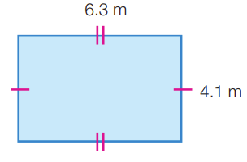 | 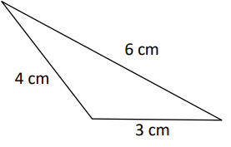

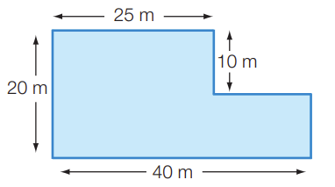 | 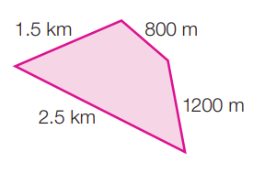
Part B - Area 6 marks

Question 3: Find the area of the following shapes. Make sure to include the correct units. [2 marks]

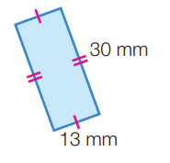 | 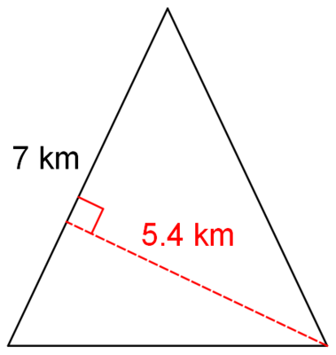

Question 4: Find the area of the composite shapes. Make sure to include the correct units. [4 marks]

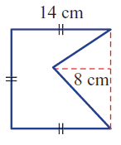 | 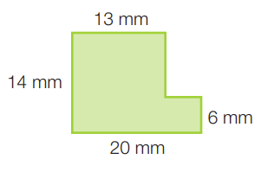
Part C – Worded Questions 6 marks

Question 5: A rectangular swimming pool is 4 m × 7 m. [1, 2, 1, 2 = 6 marks]
- What is the area of the swimming pool?

The swimming pool is surrounded by a path that is 1 m wide.

- What are the dimensions of the swimming pool including the path? Draw a labelled picture

- What is the area of the swimming pool including the path?

- If the pool fence panels only came in 2m lengths, how many fence panels will we need to fence around outside the path?

